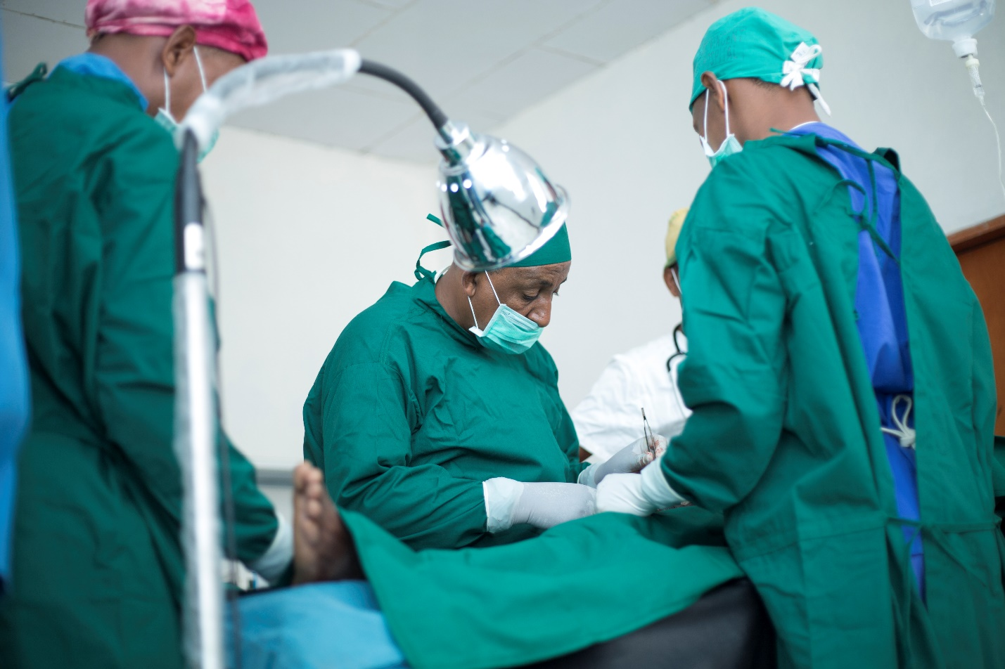

Filaricele Surgery Training Package

1. Foreword to the Filaricele Surgery Training Package
The Filaricele Surgery Training Package has been developed as part of the global effort to eliminate lymphatic filariasis (LF) as a public health problem. One of the criteria of elimination that the World Health Organization (WHO) has set is an endemic country’s capacity to manage morbidity and prevent disability due to LF. This training package is designed to assist countries to train surgical care providers to perform filaricele surgery and by doing so ensure that those men suffering from filaricele will have access to high-quality surgical services.
The Filaricele Surgery Training Package complements traditional training of surgical care providers (referred to as “surgeons” throughout the training package) by providing a standardized approach to the classroom training that needs to take place prior to the surgeon-in-training entering the operating room to first observe a surgery and then to operate on live patients.
This package also introduces the use of the Filaricele Anatomical Surgical Task Trainer (FASTT), a surgical simulator that provides surgeons-in-training with a “bridge” between the classroom sessions and operating on a live patient. The FASTT simulator features the resection technique and focuses on the key surgical skills of incision-making, blunt dissection, and suturing, three of the important components of hydrocele surgery. The simulator allows the trainer to assess the surgical skills of the trainees to ensure they have the requisite skills before they are allowed to operate on a live patient. The Filaricele Surgery Training Package is not dependent on a country having the FASTT simulator and can be used independently.
This training package was developed by the Morbidity Management and Disability Prevention (MMDP) Project, a global project to relieve suffering from lymphatic filariasis and blinding trachoma, managed by Helen Keller International (HKI) and funded by the United States Agency for International Development (USAID). It contains:
2. Facilitator’s Guide for Filaricele Surgery Training. This guide outlines the process for using the package’s PowerPoint (PPT) slide decks (3a-3d. Filaricele Surgery Training Presentations) and accompanying videos (4. Filaricele Surgery Training Videos) to train surgeons on filaricele surgery.
3a-3d. Filaricele Surgery Training Presentations. This set of PPT slide decks contains presentations for an instructor to use when training surgeons. The slide deck references the videos from 4. Filaricele Surgery Training Videos.
4. Filaricele Surgery Training Videos. This series of short videos illustrates key concepts covered in the training, including narrated demonstration of surgical technique both with FASTT and with live patients.
5. Filaricele Surgery Training Agenda. This sample training agenda offers a structure for training surgeons using the materials provided in the package, with illustrative timing.
6. Resource and Reference Materials. This compilation of supplementary materials provides additional resources and references for both the trainer and the trainees, including handouts for use during the training.
This training package reflects the current consensus on the best approaches to offering safe and high-quality surgery as outlined in the WHO report Surgical Approaches to the Urogenital Manifestations of Lymphatic Filariasis (published in 2019; https://www.who.int/lymphatic_filariasis/resources/who-cds-ntd-pct-2019.04/en/). The package is designed to be a guide and not a prescription of how things should be done. National programs should adapt the content to the context of the country and to the training programs currently being implemented for filaricele surgery.
In developing this manual, many thanks go to Dr. Sunny Mante of the African Lymphatic Filariasis Morbidity Project; Dr. Catherine deVries of the University of Utah; Ms. Zeina Sifri, Ms. Sabrina La Torre and Ms. Katie Nerses, all former staff on the MMDP Project, and Mr. Chad MacArthur, Ms. Stephanie Parker, and Ms. Geri Kemper of the MMDP Project.

