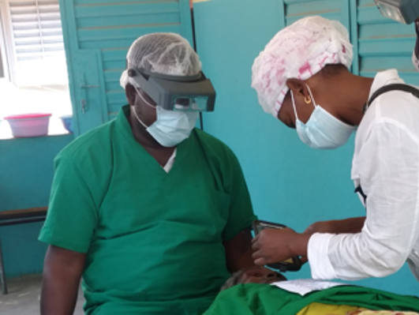
Photographing Eyelids Before and After Trachomatous Trichiasis (TT) Surgery:
A Resource Package

1. Introduction to the Resource Package
The World Health Organization’s goal for the global elimination of trachoma as a public health problem includes the reduction of trachomatous trichiasis (TT) to less than 0.2% among the adult population (15 years of age and older) in each endemic district. Globally, hundreds of thousands of people are provided with surgery to correct TT. At this high-volume level, the global campaign is also dedicated to ensuring that these surgeries are of the highest quality.
Studies examining predictors of TT surgery outcomes show that eyelid appearance immediately after surgery may be a key predictor of surgical outcomes, including poor cosmetic results, common complications, and post-operative trichiasis., This link is leading ministries of health, implementing partners, and research institutions to explore potential interventions and activities that could ultimately be used to improve the quality of surgery provided, particularly in settings where resources are limited and rates of follow-up can be low. Taking photos of eyelids pre-operatively and immediately following surgery is one such activity. Evaluating photos of an eyelid at these key time points can identify characteristics that reveal information about the quality of surgery provided. This information can then inform discussions among surgeons and/or technical supervisors on how to strengthen surgical capacity. Using photos in this way can serve as a complement to other quality assurance measures a program is implementing. The premise of this activity is as follows:
- Some negative surgical outcomes can be avoided through immediate correction or adjustment immediately after surgery.
- Eyelid appearance immediately post-surgery is a predictor of surgical outcome within 3-6 months post-operatively.
- Surgeon awareness of the post-surgical eyelid appearance as a predictor of surgical outcomes can potentially improve quality.
- Photos can be a tool to enhance a surgeon’s focus and assessment of post-surgery eyelid appearance and encourage timely corrective action.
The Morbidity Management and Disability Prevention Project, managed by Helen Keller International and funded by the United States Agency for International Development, has developed this resource package, titled Photographing Eyelids Before and After Trachomatous Trichiasis (TT) Surgery, that highlights the use of photo taking as a means to improve TT surgical quality for national programs and their partners. In addition to this document (1. Introduction to the Resource Package), the resource package includes:
2. Photographing Eyelids Before and After TT Surgery: Activity Overview. This introductory PowerPoint (PPT) slide deck is designed for national coordinators and other ministry of health officials to explain the objectives of the activity and the expected outcomes.
3a. Facilitator’s Guide for Photo Taking Training. The guide is designed to train individuals on how to take photos with sufficient image quality that surgeons and technical supervisors may use the images to review surgical quality, discuss potential surgical outcomes, and consider corrective actions that could be taken to improve outcomes. It should be used in tandem with 3b. Photo Taking Training.
3b. Photo Taking Training. This PPT slide deck outlines how to take high-quality photos of operated eyelids before and after surgery. It accompanies 3a. Facilitator’s Guide for Photo Taking Training.
4. Field Guide for Taking High-Quality Photos. This two-page tool provides tips and reminders on how to take a quality photo of an eyelid. It is designed to be printed and used in the field.
5a. Facilitator’s Guide for Reviewing Photos with Forms. This guide outlines the process for technical supervisors to use in reviewing the photos, providing feedback to surgeons, and using the feedback to identify plans for capacity strengthening. It contains standardized forms for supervisors and surgeons to use when assessing an operated eyelid through photos.
5b. Presentation for Reviewing Photos. This PPT slide deck accompanies 5a. Facilitator’s Guide for Reviewing Photos with Forms. It guides attendees through the process of reviewing and discussing photos and completing the standardized forms.
6. Photo Taking Implementation Guidelines. This document outlines key logistical and operational considerations for national programs and partners who choose to pilot or integrate photo taking as part of their TT surgical program.
This resource package has been tested in two countries, Burkina Faso and Cameroon. The feedback on the use of the full package has been positive with surgeons, technical supervisors, and program managers reporting that reviewing photos provides a useful framework for identifying characteristics that can lead to post-operative complications. This framework can facilitate discussion between surgeons and technical supervisors on potential areas for further improvement of surgical skill and act as a broader quality assurance strategy for TT service provision for the national program. As with any new activity, taking photos of eyelids before and after surgery requires some sensitization, including discussing how to take photos without disrupting the flow of patients and the actual surgery. The lessons learned during pilot testing of these resources are shared as part of 6. Photo Taking Implementation Guidelines.
Programs may also wish to explore additional uses for photos of operated eyelids and how this activity can provide
- a secondary means of supervision, including remote supervision;
- a means for surgeons to evaluate their own work;
- a tool for supervisors to identify strengths and weaknesses of individual surgeons;
- evidence to tailor refresher training;
- a means to prioritize cases for 3-6 months follow-up if 100% cannot be achieved; and/or
- the national trachoma program with an overview of the quality of the surgical services in general.

Merbs S.L., Harding J. C., Cassard S.D., Munoz B.E., West S.K., Gower E.W. “Relationship between immediate post-operative appearance and 6-week operative outcome in trichiasis.” PLoS Negl Trop Dis. 2012 Jul; 6(7): e1718.
Habmatu E., Wondie T., Aweke S., et.al. “Predictors of trachomatous trichiasis surgery outcome.” Ophthalmology 2017-03-16; 1-13.

