2. Facilitator's Guide for Filaricele Surgery Training
This document is one component of a larger training package titled Filaricele Surgery Training Package.
This Facilitator’s Guide is designed to assist the person(s) responsible for training surgical care providers and supporting members of the surgical team on filaricele surgery. The training sessions outlined in this guide offer a standardized approach to the classroom training that needs to take place prior to the surgeon-in-training entering the operating room to first observe a surgery and then to operate on live patients.
This guide outlines the objectives, duration, materials, preparation, and process for 28 different sessions covering a range of topics related to filaricele surgery. The training also introduces the use of the Filaricele Anatomical Surgical Task Trainer (FASTT), a surgical simulator that provides surgeons-in-training with a “bridge” between the classroom sessions and operating on a live patient. The FASTT simulator features the resection technique and focuses on the key surgical skills of incision-making, blunt dissection, and suturing, three important components of hydrocele surgery. Use of the FASTT simulator as part of this training is optional. The optional FASTT-related components of the training are noted throughout the guide and accompanying slides.
This guide should be used with the accompanying:
- PowerPoint (PPT) slide decks in 3a-3d. Filaricele Surgery Training Presentations,
- videos in 4. Filaricele Surgery Training Videos
- sample training agenda provided in 5. Filaricele Surgery Training Agenda, and
- supplementary files provided in 6. Resource and Reference Materials.
Important Note: Removing or adding any slides in 3a-3d. Filaricele Surgery Training Presentations will change the automated slide numbering and require updating of the slide numbers referenced throughout this facilitator’s guide.
In addition, an annex of participant handouts is included at the end of the guide. The facilitator may choose to print and use these handouts during the training.

Day 1, Section A

Session 1: Introductions
Session Summary: This session allows for participants to get to know one another. At the very minimum, names, positions, and experience in the elimination of lymphatic filariasis (LF)—particularly in filaricele surgery—should be shared. It is recommended that an icebreaker be used to demonstrate the participative nature of the workshop and to break down the barriers of formality. There are any number of such activities to choose from, and the facilitator has the discretion to choose one s/he is most comfortable with. One is suggested below.

Objectives:
- To demonstrate this is a participatory workshop and expects full participation from each learner
- To demonstrate that the participants are responsible for their learning and the facilitator is there to facilitate the learning but not impose it
- To allow the participants and facilitator to interact and to get to know one another, creating a sense of community and safety within the learning environment

Learning Objectives: N/A
Duration: 45 minutes
Materials: None
Handouts: None
Pre-session Preparation: Choose icebreaker activity to do with the group (an example is offered below)
Process:
- Ask the participants to form a circle that also includes the facilitator.
- The facilitator tells the participants that one by one each person will start by announcing their name accompanied by a gesture (such as hands raised above head, a dance step, a jump, etc.).
- The next person must say the name of the first person, replicate the gesture, and state his/her own name accompanied by a different gesture.
- The third person must say the names and replicate the gestures of each of the people before and then add his/her name and unique gesture.
- This is continued all the way around to the last person, who needs to remember everyone’s names and gestures.
- Following this activity, the facilitator asks the participants to comment on the value of such an activity in terms of team building, noting that this is something that will be discussed later on as part of the workshop.

Session 2: Introduction to Lymphatic Filariasis and Filaricele Surgery
Session Summary: This session sets the stage for the workshop that follows. It provides the justification for the workshop through an overview of LF and the global public health approach to both stop transmission and to manage the morbidity consequences of the disease. The suggested activity below is to provide the participants with the opportunity to respond both individually and collectively to a set of discussion questions concerning LF. This is followed by a video presenting an overview of LF. An optional video showing the life cycle of Wucheria Bancrofti is also available and may be shown in conjunction with the overview video at the facilitator’s discretion.
Objectives:
- To provide the context for the workshop on filaricele surgery
- To ensure all participants have the same basis of knowledge of LF and particularly of managing associated morbidity
- To introduce a group work activity (discussion of a set of five questions) that encourages learning from each other and working as a team

Learning Objectives: By the end of this session, the participants should be able to:
- Name the two aspects of elimination of LF as a public health problem
- Name the two different surgical approaches for hydrocele

Duration: 45 minutes
Materials: Computer, projector, 3a. Filaricele Surgery Training Presentation_Section A, and two videos: Video 01: Lymphatic Filariasis Overview and Video 02: Lifecycle of Wucheria Bancrofti (optional)
Handouts: Printed copies of Discussion 1: Lymphatic Filariasis Overview Questions (alternatively, the questions can be projected)
Discussion 1. Lymphatic Filariasis Overview Questions
- What are the two aspects of elimination of LF as a public health problem?
- What drugs are distributed during mass drug administration for LF?
- How many men worldwide suffer from hydrocele?
- What are two different surgical approaches for hydrocele?
- How many men are estimated to have hydrocele in your country?

Pre-session Preparation: Prior to the session, the facilitator should decide if the optional video will be shown, prepare the video(s) to play during the session, and print copies of the handout.
Process:
- Introduce the session, explaining that the next 45 minutes are to provide the overall context and justification for training filaricele surgeons.

- Distribute Discussion 1: Lymphatic Filariasis Overview Questions to each participant (or project the questions, found on Section A slide #6).
- Tell the participants they have 5-6 minutes to answer the questions.
- After 5 minutes ask the participants to either form pairs or groups of three.
- Ask the participants to share their answers with each other and then come to a group consensus as to the right answer.
- Bring the participants back together and go through the questions, discussing the answers and clarifying any misconceptions about the disease.

- Following the discussion questions, show Video 01: Lymphatic Filariasis Overview. This video may be shown in conjunction with Video 02: Life Cycle of Wucheria Bancrofti (optional), depending on time and on participants’ interest. Section A slides #7-8 indicate when to show these videos.
- At the conclusion of the video, ask the participants for any questions they have and any thoughts or questions concerning LF.

Session 3: Overview of Lymphatic Filariasis in [name of country]
Session Summary: This session provides more specific context, looking at the problem of LF in the country where the workshop is being held. The presentation should include the epidemiology of LF; the districts where LF is most endemic; the progress made through Mass Drug Administration (MDA); the estimates of the number of men with hydrocele and the number of people with lymphedema; and the current activities, successes, and challenges the national program has had with managing morbidity due to LF. The number of hydrocele surgeons currently practicing surgery and where they are located are also important points of information for the participants to be aware of.
Objectives:
- To provide the participants with a detailed profile of LF in [name of country]
- To provide further justification for the need of filaricele surgical training
Learning Objectives: By the end of this session, the participants should be able to:
- Describe where LF is present in their country
- Explain the national program’s management of morbidity due to LF, including the extent to which hydrocele surgery is currently taking place
Duration: 45 minutes
Materials: Computer, projector, 3a. Filaricele Surgery Training Presentation_Section A, and a presentation from the representative of the national LF program
Handouts: None
Pre-session Preparation: The facilitator should ensure the presence of a representative of the national program with a prepared presentation touching on the points noted above in the session summary.
Process:
- The facilitator introduces the representative of the national LF program, explaining the objective of the session.
- The representative of the national program gives his/her presentation.
- At the conclusion of the presentation, the facilitator asks if there are any questions.

Session 4: Introduction to Filaricele Surgery Training Package
Session Summary: This is an introductory session to the overall training package. It provides an overview of what the participants can expect during the training workshop and the training methodologies that will be used. This session has an accompanying video.
Objectives:
- To present the objectives of the overall workshop
- To provide the participants with an overview of the training plan and agenda
- To provide the opportunity to bring up the importance of conducting surgery safely and having high-quality surgical results
Learning Objectives: By the end of this session, the participants should be able to:
- Explain why this training is important

Duration: 30 minutes
Materials: Computer, projector, flash drives, 3a. Filaricele Surgery Training Presentation_Section A, and Video 03: Introduction to Training Package
Handouts: Flash drives containing the WHO Surgical Approaches to the Urogenital Manifestations of Lymphatic Filariasis report
Pre-session Preparation: Determine whether the Filaricele Anatomical Surgical Task Trainer (FASTT) will be used during the training; load flash drives with WHO report
Process:
- Referring to the previous video(s) and the presentation of LF in [name of country], discuss with the participants the importance of mobilizing personnel to address the problem.
- Inform the participants that the training program is designed to not only train surgeons and surgical teams but also to promote safety in surgery and high-quality surgical outcomes.
- Show Section A slide #12, listing the training approaches that will be used.
- Inform the participants whether the training will include the use of FASTT. If FASTT is not to be used, let the participants know that it may be mentioned in some of the training materials but although it is a good tool, not all countries have the funds to purchase it.
- Show Video 3: Introduction to the Training Package. Section A slide #13 indicates when to show the video.
- At the conclusion of the video, ask the participants if they have any questions.

Session 5: Targeting Safe Surgery and High-Quality Results
Session Summary: This session is designed to reinforce previous points regarding the need for conducting safe surgery that produces high-quality results. The accompanying slides discuss the WHO-recommended indicators to use in monitoring surgical outcomes and, by extension, the overall national surgical program. The national program may also have other indicators specific to the context of the country that can be included as well.
Objectives:
- To provide participants with the indicators that WHO recommends in order to monitor surgeons’ results and national program progress
- To provide an opportunity to discuss other indicators the surgeons and national program feel would be important to include
- To discuss the challenges to, and solutions for, ensuring safety in filaricele surgery and consistently achieving high-quality surgical results
Learning Objectives: By the end of this session, the participants should be able to:
- Name the WHO-recommended indicators for filaricele surgery
- Name any additional indicators tracked by the national program
Duration: 30 minutes
Materials: Computer, projector, flip chart paper, markers, and 3a. Filaricele Surgery Training Presentation_Section A
Handouts: None
Pre-session Preparation: Develop a list or slide to show additional LF indicators from the national program if they are different than the WHO-recommended indicators.
Process:
- Ask the participants what indicators they think would be appropriate, writing the responses on flip chart paper. (Some of the responses may be in more general surgical terms if the participants do not have experience with filaricele surgery.)
- When there are no further suggestions, present Section A slide #15 listing the WHO-recommended indicators.
- In presenting these indicators specific to filaricele, also discuss how they relate to the more general ones that may have been mentioned during step 1 above.
- Respond to any questions participants may have or, alternatively, ask other participants to respond to the questions.
- Present the national program indicators if they differ from the indicators that were just presented.
- Finish the session by presenting Section A slide #16, again affirming the importance of safety and quality.

Session 6: Anatomy of the Male Reproductive System
Session Summary: This is a critical session, particularly for those with no experience in filaricele surgery, as it introduces the participants to the anatomy of the male genitalia. An animated video provides the basics and an accompanying slide offers more detailed information on the layers (fascia) and muscles that will need to be incised to reach the hydrocele. The WHO Surgical Approaches to the Urogenital Manifestations of Lymphatic Filariasis report also offers additional information on the anatomy and should be referred to during the session. The session begins with group work, asking participants to identify the various parts of the male scrotum they are familiar with. This will help the facilitator to assess the knowledge the participants already have as well as the knowledge they will need to gain prior to operating on patients; it also provides an opportunity for shared learning.
Objectives:
- To allow the facilitator to determine the level of knowledge of the anatomy of the scrotum among the participants
- To present the anatomy of the male genitalia as it relates to filaricele surgery
- To provide a visual cross section of the male scrotum
- To identify the different layers and muscles comprising the scrotal sac
- To indicate to the participants various structures that if injured during surgery may cause infertility; these include the testicular vessels, the epididymis, and the ductus deferens
Learning Objectives: By the end of this session, the participants should be able to:
- Name the key anatomical structures of the male scrotum
- Name those structures which, if injured during surgery, may cause infertility

Duration: 60 minutes
Materials: Computer, projector, flip chart paper, markers, flash drives, 3a. Filaricele Surgery Training Presentation_Section A, and Video 04: Anatomy of the Male Reproductive System
Handouts: Anatomy of Male Scrotum and flash drives containing the WHO Surgical Approaches to the Urogenital Manifestations of Lymphatic Filariasis report
Pre-session Preparation: Print handout and load flash drives with WHO report
Process:
- Ask the participants to form groups of two or three, whichever would be more appropriate for the size of the workshop.
- Distribute the blank Anatomy of Male Scrotum handout to each group and ask the groups to identify and write in the names of the various anatomical parts.
- After 10-15 minutes, project the graphic (using Section A slide #18) and ask the various groups/participants the results of their work. Discuss the details included in the Notes section of the slide.
- Review the results, correcting as necessary and discussing the function of each of the parts.
- Play Video 04: Anatomy of the Male Reproductive System. Section A slide #19 indicates when to show the video.
- After the video has finished, inform the participants that this is a very simplistic view of the anatomy and project Section A slide #20, which shows more details of the layers and muscles of the male scrotum.
- Bring the session to a close by distributing the flash drives and recommending the participants study Section 5 of the WHO Surgical Approaches to the Urogenital Manifestations of Lymphatic Filariasis report for more details on anatomy.

Session 7: Staging and Grading of Hydrocele
Session Summary: This session builds on the previous one, particularly the animated video that demonstrates the scrotal sac filling with lymphatic fluid. In this session, the various stages (referring to size) and grades (referring to relationship of scrotum to the penis) of hydrocele will be presented to prepare the participants for performing pre-operative assessments. The stages and grades developed by Capuano and Capuano are presented here. It is possible the national program uses another system, which can be substituted. The important message here is the need for consistent/standardized reporting.
Objectives:
- To introduce the two measurements of hydrocele (staging and grading)
- To emphasize the importance of common terminology and a standardized system of measurement for accurate reporting
Learning Objectives: By the end of this session, the participants should be able to:
- State what both grading and staging refer to
- Describe the various stages of hydrocele
- Describe the various grades of hydrocele
- Look at a picture of a hydrocele and correctly name the stage and grade
Duration: 45 minutes
Materials: Computer, projector, flip chart paper, markers, and 3a. Filaricele Surgery Training Presentation_Section A
Handouts: Staging and Grading Chart
Pre-session Preparation: Print handout
Process:
- Introduce this session by commenting on the importance of having a standardized way to discuss hydroceles.
- Ask the participants why this is important, noting answers on the flip chart.
- Introduce the system developed by Capuano and Capuano, which has two measurements: grade and stage.
- Ask if any of the participants can define either one as they pertain to hydrocele. (Stage refers to size of the hydrocele and grade refers to the scrotum in relationship to the penis.)
- Present Section A slide #22, the Staging and Grading Chart, and read through the various stages and grades with the participants.
- Proceed to Section A slide #23 showing the various stages, referring to the descriptions for each stage in the chart shown in the previous slide.
- Proceed to Section A slide #24 showing the various grades of hydroceles, also referring to the descriptions in the Staging and Grading Chart shown previously.
- Close the session by asking the participants to review the stages and grades on their own time and provide them with the Staging and Grading Chart handout.

Session 8: Clinical Assessment
Session Summary: This session walks surgeons through the diagnostic examination for hydrocele. It details WHO-recommended methods for diagnosing hydrocele and detecting other scrotal pathologies. This session will also reinforce the importance of counseling and consenting the patient based on the findings of the clinical assessment. A video discussing clinical assessment accompanies this session.
Objectives:
- To introduce methods to employ during examination to diagnose hydrocele
- To present signs and symptoms that may indicate other scrotal pathologies
- To identify other tests that should be done at the same time as a hydrocele exam
- To provide treatment options for patients who present with other pathologies
Learning Objectives: By the end of this session, participants should be able to:
- List all the facets of a clinical assessment
- Explain each of the three diagnostic tests for filaricele and identify which one is recommended by WHO
- Be able to explain the referral or treatment protocol for complex diagnoses
Duration: 60 minutes
Materials: Computer, projector, flip chart paper, markers, 3a. Filaricele Surgery Training Presentation_Section A, and Video 05: Clinical Assessment
Handouts: Printed copies of Discussion 2. Clinical Assessment Questions (alternatively – the questions can be projected)
Discussion 2. Clinical Assessment Questions
- What is the importance of the clinical assessment?
- Why is ultrasound preferred over transillumination?
- Why is it important to check the penis and the leg, as well as the scrotum?
- What is informed consent?
- Why is it important to inform patients of the risks of surgery and get their consent?
- What other aspects of counseling and consent would you add to the video?

Pre-session Preparation: Print handout (Discussion 2. Clinical Assessment Questions).
Process:
- Introduce the session by telling the participants that this next section will present the different facets of a clinical assessment as part of pre-operative screening.
- Ask the participants what from their experience are the common facets of a clinical assessment. Write the responses on flip chart paper.
- Next, present the slide entitled “Clinical Assessment” (Section A slide #26), highlighting those aspects that participants have already stated.
- Review the facets of pre-operative screening listed on Section A slide #27 with the participants.
- Ask the participants if there are other examinations typically included in their examination protocols that they feel should be included or are required by the medical system in their country. Note the responses on flip chart paper.
- Ask the participants what three diagnostic tests for filaricele are generally used. (Ultrasound, transillumination, and palpation are generally used.)
- Present Section A slides #28-29 and discuss the fact that the WHO recommends ultrasound, but that transillumination or palpation can be used in tandem with—or in place of—ultrasound only if it is not accessible.
- Discuss the options available in the country and in endemic areas, and what technique is generally used.
- Ask the participants what other scrotal pathologies they might encounter and how they present similarly or differently to filaricele.
- Next, show Section A slides #30-32 that present other scrotal pathologies surgeons may encounter during a clinical exam and emphasize the protocols for complex diagnoses.
- Remind them that if they encounter a co-morbidity that they are equipped to fix with surgery, they must have received informed consent for that procedure, as well as for the filaricele surgery, beforehand.
- Present Section A slide #33, which defines the facility levels that are referenced when discussing referrals. Ask the participants to identify the local facilities that best correspond to the levels presented in the slide.

- Show Video 05: Clinical Assessment. Section A slide #34 indicates when to show this video.

- Distribute Discussion 2. Clinical Assessment Questions to each participant (or project the questions, found on Section A slide #36).
- Tell the participants they have 5-6 minutes to answer the questions.
- After 5 minutes ask the participants to either form pairs or groups of three.
- Ask the participants to share their answers with each other and then come to a group consensus as to the right answer.
- Bring the participants back together and go through the questions, discussing the answers and clarifying any misconceptions. Leave ample time for participants to give multiple answers or engage in discussion around the answers given.

Session 9: Management Plan and Contraindications for Surgery
Session Summary: This session will familiarize surgeons with contraindications for surgery and assist them in determining the best course of care for patients who may have other scrotal pathologies. This is the first step in the development of a well-thought-out management plan, which is one that takes into consideration various factors of the patient’s health. This in turn will help promote quality surgical outcomes and patient satisfaction.
Objectives:
- To identify contraindications for surgery or factors that influence whether surgeons should conduct hydrocele surgery or not
- To review surgical treatment options for necrotic testes and hernia
Learning Objectives: By the end of this session, participants should be able to:
- List patient, surgeon, and environmental factors that would preclude surgeons and members of the surgical team from operating
- Identify places where they can find more information on hernia repair and orchiectomy
Duration: 60 minutes
Materials: Computer, projector, flip chart paper, markers, and 3a. Filaricele Surgery Training Presentation_Section A
Handouts: Surgical Planning Algorithm
Pre-session Preparation: Print handout
Process:
- Introduce the session by presenting Section A slide #38 and discussing with the attendees that there are certain surgeon, patient, and environmental factors that may preclude them from operating, even if a patient has filaricele. Clarify that environmental factors refer to the condition of the hospital, equipment, and resources available.
- On the flip chart paper, write four column headings: Surgeon Factors, Surgical Team Member Factors, Patient Factors, and Environmental Factors.
- Ask the surgeons to identify what general factors these might be and write the answers on the flip chart under the appropriate column.
- After the group has come up with enough answers so that no one else is offering a response, present Section A slide #39 titled “Contraindications for Surgery” and ask them to comment on factors presented on the slide that they may not have thought of.
- Continue into the next point by stating that these factors are important to consider when developing a management plan for the patient. Ask participants to define a management plan and explain how they create management plans for their patients.
- Present the flowchart on Section A slide #40, which demonstrates the general process they should use when developing a management plan. Connect what is on the slide to what participants may have mentioned to demonstrate how their experience mirrors the recommendations.

- Present the key points of developing a management plan listed on Section A slide #41.

- Next, show participants an example of an algorithm (Surgical Planning Algorithm handout) that can be used to determine whether or not a hydrocelectomy should be conducted (using Section A slide #42). Explain that this is a guide and cannot account for each specific scenario they might encounter. Encourage them to develop their own algorithms, expanding on the one presented here to help them to determine the best course of action in their work.
- Finally, present Section slide #43 on hernia repair and orchiectomy, as hernia and necrotic testes can be common co-morbidities with hydrocele. Ask participants if they have encountered either of those co-morbidities before in their work. Remind the participants that they need to anticipate the possibility of encountering these co-morbidities, so the possibility should be part of the discussion with the patient prior to surgery; it will be important to obtain prior consent if additional procedures are found to be necessary during the surgery.

Day 2, Section B

Session 10: Ensuring a Safe Surgical Environment
Session Summary: The purpose of this session is to remind surgeons and other members of the surgical team of the importance of keeping the operating room clean. It presents information from the WHO Guidelines on Prevention of Surgical Site Infections and Guidelines on Hand Hygiene.
Objectives:
- To describe all aspects of ensuring a clean, safe surgical environment
- To provide cleaning requirements for the operating room
- To reinforce the importance of handwashing for surgical teams
- To describe the sterilization process
Learning Objectives: By the end of this session, participants will be able to:
- List the general principles of ensuring a clean, safe surgical environment
- Identify when each part of the operating room should be cleaned
- State the importance of handwashing and demonstrate the proper handwashing technique
- Explain the process of cleaning and sterilizing instruments
Duration: 60 minutes
Materials: Computer, projector, flip chart paper, markers, 3b. Filaricele Surgery Training Presentation_Section B, colored handprints, and tape
Handouts: Discussion 3. Hygienic Environmental Questions and two handouts: Hygienic Environment and Surgical Hand Scrubbing Technique

Discussion 3. Hygienic Environment Questions
- What are the general principles for environmental cleaning?
- What are the risks to patients and health care providers if surgical surfaces are not cleaned on schedule?
- What are the risks to patients and health care providers if instruments are not sterilized properly?
- Why is it important to have the equipment and human resources available to closely monitor the patient during surgery?

Pre-session Preparation: Print handouts
Process:
- Begin this section by asking participants how often the operating room should be cleaned. Then ask them:
  - “When is it cleaned?” and
  - “What are some of the general rules for ensuring the operating room is properly cleaned?”
- After participants respond, present Section B slides #4-6. Ask the participants to reflect on anything they did not mention when they described their process for cleaning the operating room.
- Present the table on cleaning requirements for the operating room (Section B slide #7) and ask if participants have any questions.
- Next, explain the exercise that will put to the test the information that was just presented on what should be cleaned in the operating room and how often. Present Section B slide #8 that includes a picture of an operating room.
- Ask the participants to identify each item in the operating room, making sure that each item is understood by the participants.
- Then, bring out the printed handprints and explain that each color corresponds to a frequency of cleaning that is displayed in the legend on the picture. Then, ask for volunteers to put the handprints items in the operating room using tape, basing their decisions on the information that was just presented on how often each item should be cleaned. Ask for multiple volunteers, changing volunteers when changing the color of the handprint (i.e., have one participant put the blue handprints on the picture and have another participant put up all the purple handprints).
- After all the handprints have been added to the picture, ask all participants if they believe the handprints were placed correctly. If they believe they were not, invite them to come up and make the appropriate change. Continue this until there is relative consensus that the handprints are correct where they are.
- Then, show the original photo, Section B slide #9, as presented in the WHO report. Ask participants how their photo differs from the WHO photo, if at all, and present the information given previously that supports the WHO hand placement.
- Present Section B slides #10-12 and talk about how it is important to follow good personal hygiene practices before entering the operating room. Ask participants why it is important to ensure access to adequate hygiene facilities and practice surgical handrubbing. Tell them they will have access to the surgical hand rubbing technique infographic through their resource package and do not spend time walking through all the steps.
- Next, explain that a clean surgical environment includes the instruments used during surgery. Present Section B slides #13-14 on sterilization and remind participants that disinfecting instruments is no longer recommended by the WHO.
- Present Section B slide #15, which gives links to the WHO reports that informed these slides, should the participants want to look through the recommendations themselves.
- Finish the session with Section B slide #17, which contains discussion questions that review information covered on environmental preparation. Distribute Discussion 3. Hygienic Environmental Questions to each participant.
- Tell the participants they have 5-6 minutes to answer the questions.
- After 5 minutes, ask the participants to either form pairs or groups of three.
- Ask the participants to share their answers with each other and then come to a group consensus as to the right answer.
- Bring the participants back together and moderate a discussion among participants as they answer these questions. Encourage participants to comment on other people’s responses or pose their own questions to the group. Distribute the Hygienic Environment and Surgical Hand Scrubbing Technique handouts to participants.

Session 11: Team Process and the Surgical Environment
Session Summary: This section will present a concept called team process, which refers to the coordination and cooperation of all surgical team members in preparation for surgery. The section will also give participants the space to think critically about how these processes affect the patient, not simply the surgical staff.
Objectives:
- To define team process and explain what team processes are in the context of surgery
- To demonstrate the interconnectivity of surgical team activities and the importance of good coordination
- To recommend standardizing processes to improve quality of surgery
Learning Objectives: By the end of this session, participants should be able to:
- Define team process
- List activities that are team processes
- Explain how team process activities affect patient outcomes
Duration: 60 minutes
Materials: Computer, projector, flip chart paper, markers, and 3b. Filaricele Surgery Training Presentation Section B
Handouts: Blank sheet of paper per group
Pre-session Preparation: Obtain blank sheets of paper to use in activity described below.
Process:
- Introduce this section with Section B slide #19 and ask the participants what team process means to them as it relates to surgery, noting responses on flip chart paper.
- Ask participants to identify some examples of team processes in surgery.
- Then, have participants break out into small groups of 3-4 people and give them a blank sheet of paper. Ask them to write down the position names of every member of the surgical team (e.g. surgeon, scrub nurse, anesthetist, etc.) and to write them far apart on the sheet of paper.
- Next, ask them to write down some of the roles and responsibilities of each person on the surgical team underneath the position name. Tell them they can repeat their answers across different team members if multiple team members are responsible for the same task.
- Then, have them connect all the same roles across different team members with a line. So, for example, if the nurse and the anesthetist are both responsible for ensuring the proper equipment is present for providing anesthesia, you will have written it under both of their positions and connect the two entries with a line.
- Then, ask them to draw a dashed line from team members that oversee or manage certain activities to the corresponding activities under the other team members.
- Finally, ask the participants to discuss in their small groups what all those lines on their paper show about the interconnectivity of the surgical team and discuss the implications of strong teamwork on outcomes for patients.
- Bring everyone back together and ask each group to volunteer some of the talking points they discussed. Leave time for other groups to comment.
- Finish by explaining that checklists and timeouts are good ways to check in with team members and ensure proper coordination of activities. In addition, encourage participants to develop standardized processes to ensure that the surgical environment is clean and that surgical outcomes are positive.

Session 12: Preparing the Operating Room
Session Summary: This session will walk participants through the process of preparing the operating room for surgery. While we have already discussed the importance of maintaining a clean environment, this session will focus on steps to prepare for the surgery itself, including setting up the proper lighting and equipment.
Objectives:
- To present a checklist of things that need to be set up prior to surgery
- To identify the instruments needed to perform hydrocele surgery
- To explain the usage of a cautery machine
Learning Objectives: By the end of this session, participants should be able to:
- List all the steps in preparing the operating room for surgery
- Be able to identify an instrument based on a photo
- Be able to explain how to use a cautery machine
Duration: 45 minutes
Materials: Computer, projector, flip chart paper, markers, 3b. Filaricele Surgery Training Presentation_Section B, and Video 06: Preparing the Operating Room
Handouts: None
Pre-session Preparation: Test video to ensure it plays properly
Process:
- Introduce the section by reminding participants that operating room preparation is a team process that should involve all members of the surgical team.
- Ask participants to explain what should be set up in the operating room prior to surgery. Write their answers on the flipchart.
- Present Section B slide #21 and list the equipment that needs to be set up prior to surgery. Remind participants that all sharps and gauze should be counted, and the number of each should be recorded PRIOR to surgery.
- Show Video 06: Preparing the Operating Room. (Section B slide #22 indicates when to show this video.)
- Present Section B slides #23-24, which depict the instruments listed in the video, and ensure that participants understand what all those instruments look like. Remind them that if they also intend to do a hernia repair, other instruments and consumables will be necessary and that should be taken into account prior to surgery.
- Emphasize to participants that the items on the slides and those mentioned in the video are not a complete listing of all required materials.
- Using Section B slide #25, inform participants of a resource that is available to help programs quantify the amounts of drugs, disposable materials, and durable goods needed for high-quality hydrocele surgery as part of planning: the Hydrocele Surgery Procurement Calculator.
- End with Section B slide #26 showing the cautery machine. Ask participants if any of them have had previous experience using a cautery machine and ask them to explain what it does and how they use it. If more than one person has experience with a cautery machine, ask one person to explain and then ask the others if they would like to add or amend anything to the response of the first person.
- Fill in the response(s) of the participants with information from the slide and ask participants if they have any question about the cautery machine. End by asking them how they can achieve hemostasis without a cautery machine if one is not available.

Session 13: Sharps Management
Session Summary: This session will go into more detail on the international guidelines and protocol around sharps management. It is important to ensure that all sharps are managed properly in the surgical setting to protect patients and health care workers alike.
Objectives:
- To present the WHO-recommended protocol for sharps management to reduce injury
- To identify the necessary characteristics of a sharps disposal container
Learning Objectives: By the end of this session, the participants should be able to:
- Explain the protocol for disposing of sharps to reduce injury and avoid contamination
- List the characteristics of an appropriate sharps disposal container
Duration: 30 minutes
Materials: Computer, projector, flip chart paper, markers, 3b. Filaricele Surgery Training Presentation_Section B, and Video 07: Sharps Management
Handouts: None
Pre-session Preparation: Test video to ensure it plays properly
Process:
- Begin by telling participants that this section will review the proper protocol for sharps management and ask them to explain how to properly dispose of sharps in the operating room.
- Ask the participants how sharps are currently managed in the operating room.
- Show Video 07: Sharps Management. (Section B slide #28 indicates when to show this video.) At the end of the video, draw connections between the guidelines presented in the video and the experiences that the participants expressed earlier about how sharps are managed in their operating rooms.
- Show Section B slides #29-30. Review with the participants the reminders that explain how to dispose of sharps in order to avoid injury.
- Point out the characteristics of the sharps container. Ask participants to consider whether or not their sharps container fits all these requirements.

Session 14: Pre-Operative Care and Prevention of Surgical Site Infections
Session Summary: This session is dedicated to reviewing procedures and protocols for preparing patients to undergo filaricele surgery. The protocols are based on the WHO Guidelines for Prevention of Surgical Site Infections and intended to reduce the risk of surgical complications and post-operative infections.

Objectives:
- To familiarize participants with the WHO-recommended guidelines on preventing surgical site infections
- To review the proper procedures for preparing patients for surgery
- To reinforce the importance of patient preparation to ensure high-quality surgery
Learning Objectives: By the end of this session, the participants should be able to:
- List the tasks necessary to prepare a patient for surgery
- Be able to state the recommended procedure for bathing and hair removal
- Identify the appropriate timing of pre-exposure antibiotic prophylaxis
Duration: 45 minutes
Materials: Computer, projector, flip chart paper, markers, 3b. Filaricele Surgery Training Presentation_Section B, and two videos: Video 08: Pre-operative Care and Video 09: Patient Preparation
Handouts: Discussion 4. Pre-Operative Care Questions
Discussion 4. Pre-Operative Care Questions
- Why is it important to count the number of gauze and sharps prior to surgery?
- What two factors increase a health care provider’s risk of injury when handling sharps?
- What are the benefits of washing and disinfecting the surgical site prior to surgery?
- Why shouldn’t you shave the hair around the surgical site?
- What other steps, not mentioned here, should be taken to avoid surgical site infections?
- Why might there be an increased concern about surgical site infections with those who have hydrocele resulting from LF infection?

Pre-session Preparation: Print handout and test videos to ensure they play properly
Process:
- Begin by showing two videos: Video 08: Pre-operative Care and Video 09: Patient Preparation
as noted on Section B slides #32-33.
- Next, show the Section B slide #34 on pre-operative bathing and pre-operative antibiotic prophylaxis. Ask participants what the procedures are for pre-operative bathing and antibiotic use.
- Connect the participants’ responses to the guidelines presented on the slide. Pay attention to the recommended guidelines on antibiotic prophylaxis, referring to the WHO Surgical Approaches to the Urogenital Manifestations of Lymphatic Filariasis report for reference as needed, as these WHO recommendations may run counter to local practices.
- Remind the participants that antibiotic use should take into consideration local resistance patterns.
- Present Section B slide #35 and ask participants what their procedures are for hair removal around the surgical site.
  - Remind participants that hair removal should be done by a health care worker and not by the patient themselves.
  - Clarify that the clipping of hair should be done in the operating room and not, as is mentioned in the video, in the patient’s room after they bathe the evening prior to surgery.
- Also remind them that the goal should not be to remove all hair in the area, but just enough as is needed to ensure there is no impediment to the surgery.
- Show the Section B slide #36 about surgical site preparation. Remind the participants of what they saw in the portion of the video that demonstrated the proper technique for cleaning the area with chlorhexidine (or povidone-iodine solution) to disinfect. As you present this slide, make the connection that disinfection of the surgical site helps to reduce the risk of surgical site infections post-operatively.
- Use that connection to continue into the discussion questions on Section B slide #37. Distribute Discussion 4. Pre-Operative Care Questions to each participant (or project the questions using Section B slide #38).
- Tell the participants they have 5-6 minutes to answer the questions.
- After 5 minutes, ask the participants to either form pairs or groups of three.
- Ask the participants to share their answers with each other and then come to a group consensus as to the right answer.
- Bring the participants back together and moderate the responses and discussion that results from these questions.

Session 15: Anesthesia
Session Summary: This section covers anesthesia protocols for filaricele surgery. In this section are recommendations for the types of anesthesia that could be used and the pre-operative medications that should also be given prior to surgery. It forms recommendations based on the anesthetist capacities of the health center.
Objectives:
- To provide guidance on the appropriate anesthesia procedures for filaricele surgery
- To identify other important pre-operative medication
Learning Objectives: By the end of this session, the participants should be able to:
- Identify the situations in which it is appropriate to use spinal anesthesia
- List important pre-operative medication besides analgesia medication
- Identify when antibiotics should be taken relative to the surgery
Duration: 45 minutes
Materials: Computer, projector, flip chart paper, markers, 3b. Filaricele Surgery Training Presentation_Section B, and Video 10: Anesthesia
Handouts: None
Pre-session Preparation: Test video to ensure it plays properly
Process:
- Introduce the section by telling the participants that this section will cover the recommended anesthesia regimen for filaricele surgery and other important pre-operative considerations.
- Prior to showing the video, ask participants to reflect on some of the information presented earlier. Ask them when antibiotics should be given. Then, ask them what their current capacities are for anesthesia in their operating rooms.
- Show Video 10: Anesthesia.
- After the video, emphasize that according to the WHO Surgical Approaches to the Urogenital Manifestations of Lymphatic Filariasis report, local anesthesia is preferable in most cases. Ask participants to discuss their experiences recommending spinal versus local anesthesia, as the choice may depend on the capacity of the health center.
- Show Section B slide #41, which summarizes the information covered in the video. Remind participants that non-steroidal anti-inflammatory drugs (NSAIDs) are not recommended until after surgery, local anesthetic is the preferred practice, and that antibiotics should only be given within one hour before surgery.

Session 16: Surgical Technique
Session Summary: This session will include a video that shows a live demonstration of two different surgical techniques for filaricele surgery. Unlike the other sections of this presentation, this section centers on the video presentation as it provides a visual demonstration of the surgery itself.
Objectives:
- To present two techniques for filaricele surgery
- To demonstrate the techniques through video of a live surgery
- To identify the factors that may influence a surgeon’s decision to use one technique over the other
Learning Objectives: By the end of this session, the participants should be able to:
- Describe step by step the process of completing the resection and eversion techniques for filaricele surgery
- Identify the technical differences between resection and eversion
- Name the factors that inform the decision on which technique to use
Duration: 60 minutes
Materials: Computer, projector, flip chart paper, markers, 3b. Filaricele Surgery Training Presentation_Section B, and Video 11: Surgical Techniques
Handouts: Techniques for Tunica Vaginalis
Pre-session Preparation: Print handout and test video to ensure it plays properly
Process:
- Begin by introducing the contents of the video presentation. Using Section B slide #43, explain that the video will show a live filaricele surgery and will demonstrate two different techniques: resection (or excision) and eversion. Inform the participants that their choice of technique should be guided by local practices and their surgical training.
- Next, show Video 11: Surgical Techniques (indicated on Section B slide #44). It is a much longer video compared to the others. As a result, it may be necessary or helpful to pause the video at certain points to review with participants what was just shown. Depending on participants’ ability to digest the information from the video in real-time, it may also be necessary to rewind the video.
- At the end of the video, ask participants if they have any questions about what they just saw or if they need to review a point that was made during the video. Leave plenty of time for this part to ensure any doubts or questions are addressed.
- Give participants the Techniques for Tunica Vaginalis handout that visually depicts three different techniques for the tunica vaginalis and ask them to identify the differences in each technique.
- Finally, display Section B slide #45, which labels the different techniques.

Session 17: Cleaning Up After Surgery
Session Summary: This session will focus on the proper protocols for disposing of waste after surgery. It will cover disposal of health care waste, as sharps management was discussed in prior sessions.
Objectives:
- To review protocols for appropriate disposal of health care waste created during the surgical process
- To connect waste management with team process principles
Learning Objectives: By the end of this session, the participants should be able to:
- Name the main principles of waste management
- Be able to explain how waste management is a team process
Duration: 30 minutes
Materials: Computer, projector, flip chart paper, markers, 3b. Filaricele Surgery Training Presentation_Section B, and Video 12: Cleaning Up After Surgery
Handouts: None
Pre-session Preparation: Test video to ensure it plays properly
Process:
- Introduce this section by telling the participants it will cover the protocols for disposing of waste after surgery. Ask participants if they can identify the main principles of waste management based on their experience. Write their responses on the flipchart.
- Show Section B slide #47 and discuss with participants how it relates to what they mentioned, the importance of employing appropriate waste management protocols, and the main principles of waste management.
- Present Video 12: Cleaning up After Surgery (as indicated on Section B slide #48).
- Present the guidelines for waste management on Section B slides #49-50.
- Remind participants that waste management is also a team process. Ask them to identify the roles of each member of their surgical team in carrying out waste management. Select a few participants to share how their team goes about disposing of waste. If any participant indicates that disposal of waste falls on only one member of their surgical team, discuss with them how each member can play an active role in assisting with waste management.

Session 18: Dressing and Bandaging
Session Summary: This section will show participants how to properly disinfect, dress, and bandage the surgical wound after surgery to ensure effective healing and avoid post-operative infections.
Objectives:
- To demonstrate how to disinfect the wound after surgery
- To demonstrate the proper techniques for dressing and bandaging the surgical wound after surgery
Learning Objectives: By the end of this session, the participants should be able to:
- Explain how to disinfect the surgical wound after surgery
- Identify the steps of dressing and bandaging the wound
Duration: 30 minutes
Materials: Computer, projector, flip chart paper, markers, 3b. Filaricele Surgery Training Presentation_Section B, and Video 13: Dressing and Bandaging
Handouts: None
Pre-session Preparation: Test video to ensure it plays properly
Process:
- Introduce the section by presenting Section B slide #52. Discuss with the participants the importance of ensuring that the surgical wound is properly bandaged and supported.
- Show the accompanying Video 13: Dressing and Bandaging and ask if participants have any questions about the techniques demonstrated.

Session 19: Post-Operative Care
Session Summary: This section provides an overview of the aspects of immediate post-operative care. It focuses on the medication needs of patients in the immediate period after surgery while they are in the hospital for recovery.
Objectives:
- To provide recommendations for antibiotic use in the event of post-operative infection
- To provide information on the recommended post-operative analgesia regimen
- To identify the appropriate treatment measures for patients who are microfilaria-positive
Learning Objectives: By the end of this session, the participants should be able to:
- Describe the process for determining what antibiotic to use
- Name the type of analgesia and dosage, as well as contraindications for NSAID use
- Name the drugs and dosage of medications to prescribe for microfilaria-positive patients
Duration: 45 minutes
Materials: Computer, projector, flip chart paper, markers, and 3b. Filaricele Surgery Training Presentation_Section B
Handouts: None
Pre-session Preparation: Confirm the latest WHO guidelines/dosage for medication and update slides if needed
Process:
- Begin by presenting Section B slide #55 on post-operative antibiotic coverage. Ask participants what the recommendations are for antibiotic use after surgery, as it was mentioned earlier in the training.
- Depending on the answers given by the participants, reiterate that it is not recommended to give antibiotics after surgery unless it was a particularly complex case of hydrocele. In such cases, antibiotic choice should be based on microflora testing from the buried penis cavity.
- Indicate that if a patient develops a post-operative infection, they should be given antibiotics in accordance with local availability and resistance patterns. Gentamicin or Tobramycin are recommended, particularly Gentamicin as it is less expensive and often more widely available.
- Present Section B slide #56 on post-operative analgesia. Ask participants what NSAID stands for (“non-steroidal anti-inflammatory drug”) as it was mentioned earlier in the presentation and what the contraindications are for NSAID use.
- Use information from the slide to fill in any information that participants did not mention.
- Finally, end by discussing the treatment regimen for patients who are positive for microfilaria as they will need to be treated in addition to having the hydrocele surgery. Ask participants what the treatment is for LF, then present Section B slide #57 to give a visual of the medications and dosages for those who may not have prior knowledge of the treatment regimen.

Day 3, Section C

Session 20: Follow-Up Care
Session Summary: This section will review the procedure for follow-up care within 14 days post-operation. It will go into more detail on the dressing change procedure in the two-week period following surgery as well as important items to assess at each follow-up appointment.
Objectives:
- Explain the dressing change technique
- Identify the timing of dressing changes and what to look for during post-operative follow-up
- Make recommendations for post-operative hospital admission schedule
Learning Objectives: By the end of this session, the participants should be able to:
- List the important follow-up dates within two weeks post-operation
- State how long the patient should remain in the hospital
- Describe how dressing techniques differ as follow-up continues
- Name important signs and symptoms to be particularly aware of during post-operative follow-up
Duration: 30 minutes
Materials: Computer, projector, flip chart paper, markers, 3c. Filaricele Surgery Training Presentation_Section C, and Video 14: Follow-up Care
Handouts: Hydrocele Surgery Follow-Up Algorithm
Pre-session Preparation: Print handout and test video to ensure it plays properly
Process:
- Introduce the section by explaining that the session will focus on post-operative care within two weeks of surgery and that close post-operative follow-up is essential because infection can become quite serious in this warm, moist part of the body.
- Present the list of topics on Section C slide #4 that the accompanying video will show. Then, ask the participants if they can think of any signs or symptoms to look for during follow-up that may indicate a complication. Write responses on the flip chart.
- Tell them to keep these indicators in mind as the video goes through the timing of post-operative follow-up appointments and what to look for during each.
- Play Video 14: Follow-up Care as indicated on Section C slide #5.
- After the video, ask participants to comment on any signs or symptoms that may not have been identified prior to the video.
- Next, explain to the participants that you are going to conduct a small quiz based on a follow-up algorithm that will be available for them to use as a resource (Hydrocele Surgery Follow-up Algorithm).
- Before showing the full Section C slide #6, begin by reading to them the first step on the flow chart. Then ask the participants what the appropriate course of action should be given when hemorrhage is or is not found. Once no one else volunteers an answer, show them the responses provided by the flow chart. Ask them how the response there differs (if at all) from their answers.
- Continue doing this for each yes/no step of the flowchart until you reach the end (Section C slide #10). At the end, ask if the flowchart helped them synthesize the information presented about follow-up protocol and let them know how they can access the flowchart (shown on Section C slide #11) to use in their practice.

Session 21: Surgical Complications
Session Summary: This section will go into more specifics on common surgical complications that result from hydrocele surgery. It will show pictures of each complication and give recommendations on how each complication should be handled, if it arises.
Objectives:
- Identify common surgical complications to be aware of during post-operative follow-up
- Help participants visually identify the complications
- Provide recommendations for how the complications should be treated within the capacities of the health system
Learning Objectives: By the end of this session, the participants should be able to:
- Name the most common surgical complications from filaricele surgery
- Describe the care plan for each type of complication
- Identify the surgical complication based on photographs of an affected scrotum
Duration: 45 minutes
Materials: Computer, projector, flip chart paper, markers, and 3c. Filaricele Surgery Training Presentation_Section C
Handouts: None
Pre-session Preparation: N/A
Process:
- Ask participants to name the most likely surgical complications to arise from filaricele surgery, based on the flowchart exercise they just completed.
- Present Section C slides #13-14 which describe common surgical complications and give recommendations on how the complications should be addressed if they are diagnosed. For each complication, first ask participants how they should proceed to treat the condition and then fill in any gaps in responses with the information on the slide.
- Next, show the first picture of a scrotum post-operation (Section C slide #15), and ask the participants if there are any indications of a complication presented there. Pause to allow participants time to review the photo and form a possible diagnosis. Once it seems that no one else would like to volunteer an answer, identify who was correct in their response or, if no one was, explain to them that it is a photo of a scrotum healing well from surgery and does not present complications.
- Move to the next photo on Section C slide #16, ask the same question, and follow the same procedure to elicit responses. If someone guessed correctly, ask how he/she came to that answer. Probe by asking what in the photo led him/her to assert it was a case of hematoma. If more than one person answered, ask one person to explain his/her reasoning (unless they are unable to or someone else volunteers more information than the person you initially asked).
- Ask the participants, given the diagnosis, how should they proceed to treat the patient.
- Repeat steps 4 and 5 for the rest of the photos.

Session 22: Discharge and Long-Term Follow-Up
Session Summary: This section will review the appropriate discharge procedures for patients who underwent filaricele surgery and discuss important considerations for long-term follow-up. Long-term follow-up refers to follow-up longer than the two-week period covered by the previous section and extends, ideally, to five years post-operation.
Objectives:
- Present important information that should be given to the patient at the time of discharge
- Identify important timepoints in the context of long-term follow-up
- Provide information on the types of data that should be collected on the patient during follow-up
Learning Objectives: By the end of this session, the participants should be able to:
- List ideal follow-up intervals after the two-week post-operation period
- State the information that patients should receive while being discharged
- List important indicators to keep track of before and after hydrocele surgery
Duration: 30 minutes
Materials: Computer, projector, flip chart paper, markers, 3c. Filaricele Surgery Training Presentation_Section C, and Video 15: Long-Term Follow-up
Handouts: None
Pre-session Preparation: Test video to ensure it plays properly
Process:
- Begin by asking the participants how long the patient should be in the hospital before being discharged. Then, ask them what information they typically provide their patients who underwent a surgical procedure. Write down their responses on the flip chart.
- Present Section C slide #20 to review what information is recommended to give patients at the time of their discharge, connecting it to the information the participants gave before when the question was posed to them.
- Present Section C slide #21 to give participants an idea of the time range encompassed by the term “long-term follow-up” and explain that follow-up after the two-week period is what distinguishes the information in this section from the previous section on post-operative follow-up. Be sure to remind them that follow-up longer than one year is ideal, but not required if they do not have the capacity.
- Next, present Video 15: Long-term Follow-up (as indicated on Section C slide #22).
- After the video, ask the participants to list indicators that they should collect information on during the follow-up period. Write them on the flip chart.
- Ask them if any of those indicators should also be inquired about prior to surgery (for example, in the video it says that information on socio-economic status of the patient should be collected during follow-up but also ideally at the time of surgery).
- Ask participants why it is important, in the context of a national lymphatic filariasis program, to collect non-clinical information about patients who have undergone filaricele surgery. Discuss. Continue to ask and discuss the other discussion questions on Section C slide #23.

Session 23: Training Summary
Session Summary: This section concludes the core set of theoretical modules constituting the training workshop and provides a summary of the information covered. In addition to providing summary reminders of what was covered, it also provides more information on the resources that are available to surgeons conducting filaricele surgery that they can use in their work.
Following this session, if the FASTT surgical simulator is available, the facilitator should review Sessions 24-27 and conduct the sessions accordingly. This should be followed by the steps outlined in Session 28: Live Surgery: the trainees observing a surgery and then performing an operation on a patient under supervision. If FASTT is not available, proceed to the observation and then the supervised surgery in Session 28.
Objectives:
- Review information presented in the training workshop
- Provide information on how participants can access resources to aid them in conducting filaricele surgery
Learning Objectives: By the end of this session, the participants should be able to:
- List the resources made available in the training package
Duration: 30 minutes
Materials: Computer, projector, flip chart paper, markers, and 3c. Filaricele Surgery Training Presentation_Section C
Handouts: None
Pre-session Preparation: N/A
Process:
- Start by congratulating the participants on completing this portion of the training workshop.
- Explain that you will start by giving an overview of the information that was presented in the sections of the workshop.
- As you present Section C slides #25-27, state the names of the resources in the training package that correspond to the information presented in the section. Describe to them how they can access those training materials given what you have provided them.

Day 3, Section D

Session 24: FASTT Training Introduction [OPTIONAL – requires FASTT Surgical Simulator]
Note: If FASTT is not available, proceed to the observation and then the supervised surgery in Session 28: Live Surgery.
Session Summary: The Filaricele Anatomical Surgical Task Trainer, also known as FASTT, is a hydrocele surgery simulator developed through the USAID-funded Morbidity Management and Disability Prevention (MMDP) Project. This surgical training tool allows surgeons to hone their skills on an inanimate object before operating on a live patient. The purpose of this session to provide participants with the opportunity to practice on the FASTT surgical simulator (if available). The session reviews the critical aspects of filaricele surgery and introduces participants to the concept and purpose of using a surgical simulator for filaricele surgery training. The goal is to give participants a good understanding of what FASTT can and cannot be used for. FASTT is designed for practicing the resection technique, which involves resecting the tunica vaginalis.
The FASTT simulator features the resection technique and focuses on the key surgical skills of incision-making, blunt dissection, and suturing, three of the important components of hydrocele surgery. The size of the hydroceles that the simulator represents is Stages II-III (according to Capuano’s classification).
Additional Background on FASTT:
The FASTT surgical simulator is designed for the practical, hands-on portion of the training. It allows the instructor to demonstrate the recommended surgical techniques, and lets surgeons standardize their technique by practicing their skills under the instructor’s direct supervision. The simulator allows surgeons to practice in a safe environment without risk to the patient. As such, the FASTT surgical simulator provides an opportunity to bridge the gap between the theory-learning in the classroom and the surgical intervention on patients.
The advantage of the FASTT simulator is that it allows the surgeons to practice the incision, the blunt dissection, and the extraction of the hydrocele. There is even a blood vessel that may be cut during the incision, to allow the surgeons to practice suturing the blood vessel to stop the hemorrhaging. The simulator also provides an opportunity to practice suturing according to the recommended technique.
Some of the disadvantages of FASTT are that it of course does not exactly mimic the feel of a human hydrocele. When the incision is done, there are basically only 2 layers that will appear, the first being the skin and other membranes that are present in one layer. The second and last layer will be the tunica vaginalis. The tension that needs to be applied during the incision and retraction of the first layer is not exactly the same as that in humans but provides a good proxy. The blunt dissection is close to what it feels like in a real situation and the suction and emptying of the hydrocele is a good approximation. The tunica vaginalis on FASTT is less flexible than in humans and its resection and suturing might be slightly easier to do on FASTT than in humans.
FASTT also can be used intermittently during live surgery training. When a trainer identifies that a trainee needs additional work on a specific skill or skills, the trainer can ask the trainee to return to FASTT to practice those skills until the trainee is proficient. Additionally, the trainee can request to conduct additional surgeries on FASTT at any point during or after the live-surgery training.
Objectives:
- To describe the benefits of working with a surgical simulator before live surgery
- To introduce participants to the FASTT training system (including what it can and cannot be used for)
- To describe the role of FASTT during live surgery training and refresher training
Learning Objectives: By the end of this session, the participants should be able to:
- List benefits of working with the FASTT surgical simulator
Duration: 60 minutes
Materials: Computer, projector, 3d. Filaricele Surgery Training Presentation_Section D, and Video 16: FASTT Demonstration
Handouts: None
Pre-session Preparation:
Process:
- Begin by asking participants to name the most important aspects of filaricele surgery. Write all responses on the flip chart. As a group, discuss the critical steps and how they have been taught in the past.
- Provide an overview of the capabilities of FASTT. It allows the surgeons to practice:
  - the incision,
  - the blunt dissection,
  - the extraction of the hydrocele, and
  - suturing (including suturing the blood vessel to stop the hemorrhaging).
- Using Section D slide #4, inform the participants that FASTT is designed for practicing the resection technique, which involves resecting the tunica vaginalis. The eversion technique was presented in earlier sessions as additional information.
- Using Section D slide #5, present the goals of using FASTT as part of an initial training.
- Show Video 16: FASTT Demonstration, which demonstrates surgery performed using FASTT. The facilitator should feel to stop the video at various points to make comments and highlight various steps of the surgery.

Session 25: FASTT Training Demonstration and Familiarization [OPTIONAL – requires FASTT Surgical Simulator]
Session Summary: This session is designed to give participants the opportunity to become familiar with performing surgery on FASTT. Participants will be paired into teams of 1-2, with one trainer assigned to each team. Each participant will have his or her own base, surgical instruments, and cartridges to work with. During the demonstration session, the trainer introduces the trainee to the FASTT system. The trainer begins by introducing the name, function, and handling of each instrument needed to perform the surgery. Then the trainer performs all steps of the surgical procedure while the trainee watches. The trainer should describe each step of the procedure as he or she does it.
Objectives:
- To allow participants to become familiar with FASTT
- To begin familiarizing the participants with filaricele surgery
- To provide an opportunity for self-reflection about surgical skills and practice
Duration: 90 minutes
Materials: FASTT Kits (as described in Pre-session Preparation below)
Handouts: None
Pre-session Preparation: Prepare the training layout/setting and FASTT Kits as follows:
Training layout and setting
Select a room that is quiet with adequate lighting. Usually any meeting room type of setting will work, and the initial layout should be arranged for participants to follow presentations. Once the theoretical part is over, the tables should be arranged according to the tested and recommended set-up for using the FASTT surgical trainer as illustrated in the diagram below (Figure 1). The diagram shows three FASTT surgical simulators (orange) arranged on a table. The instructor is standing in the middle demonstrating the hydrocele surgery to four trainees (yellow) at a time. In exceptional circumstances, it is also possible to include a fifth trainee, who would stand across the table from the instructor. Usually the instructor will need an assistant, who could be another instructor or a surgeon who has already completed the FASTT training. The two trainees to the left and right of the instructor will be the surgeons, and the two others across the table, their assistants.
Figure 1: Recommended layout for FASTT Training

FASTT Kits
The main components of the FASTT trainer are a reusable base and disposable hydrocele cartridges. Each cartridge has a bilateral hydrocele, allowing a single cartridge to be used for two practice surgeries, one on each side. Before use, each side of the cartridge needs to be filled with water. To do this, you can use a large syringe or a water faucet. After filling, you should use forceps to clamp off the hoses leading into the hydrocele.
Each FASTT base will need to be accompanied by a set of surgical instruments. The instruments should be cleaned with soap and water after each training session and stored with the base and cartridges. The following instruments are included with the simulator:
- Surgical blade handle and disposable blades (one per participant), size #10
- Small artery forceps, curved
- Big artery forceps, curved
- Small needle holder to suture
- Scissors, curved
- Allis clamps, small
- Dissecting forceps – toothed, medium
The following supplies will need to be procured for each base:
- Towel clips, medium
- Surgical towels for draping
- Kidney dish (large) to empty the contents of the tunica vaginalis in
- Water source
- Large syringe to insert water into the hydrocele cartridges
- Sharps box
The following consumables will also need to be procured for each trainee/surgery:
- 3-0 Vicryl sutures
- Soap
- Betadine or similar solution
- Gauze, 4x4
- Surgical gloves
- Additional blades as needed
Process:
- Describe the initial steps of training with FASTT, beginning with the demonstration and familiarization steps.
- Organize trainees into pairs. This may be done by district and/or region. Assign one trainer to each pair.
- Start with the demonstration phase, done by the trainer.
- During the familiarization phase, the trainer should perform one step of the procedure while describing the various considerations that need to be made and then have the trainee perform the same step on their cartridge(s).
- Continue this step-by-step process through the entire surgical procedure.

Session 26: FASTT Training Practice [OPTIONAL – requires FASTT Surgical Simulator]
Session Summary: During the practice phase, the trainee performs the entire surgical procedure from start to finish, on BOTH sides of the scrotum, with the trainer providing feedback throughout the procedure, as needed. As in the familiarization step, the trainer can ask the trainee to repeat any steps that the trainee has not fully mastered.
Objectives:
- To allow the trainee to practice surgery under trainer supervision
- To allow the trainer to assess if the trainee needs more practice or is ready to move on to the solo observed procedure described below
Duration: 60 minutes
Materials: FASTT Kits (as described in Section 25 above)
Handouts: None
Pre-session Preparation: Ensure FASTT Kits are prepared in sufficient quantity for each participant
Process:
- The trainer should sit to the right of the trainee.
- Ask the trainee to demonstrate all the steps of filaricele surgery. The demonstration should start with the surgeon’s preparation (including handwashing and correct wearing of sterile gloves), and the equipment preparation.
- The trainee will then perform all steps of filaricele surgery under the trainer’s supervision.
- The trainer will provide guidance and support during the procedure and can ask the trainee to repeat a step that has not been performed satisfactorily.

Session 27: Solo Observed Surgery on FASTT [OPTIONAL – requires FASTT Surgical Simulator]
Session Summary: The trainee should complete one surgery from start to finish without input from the trainer. The trainer should watch closely throughout the procedure, taking notes about areas of excellence and areas needing improvement. At the end of the procedure, the trainer should decide whether more FASTT training is needed or whether the trainee is ready to perform surgery on live humans. Trainees should be made to feel that there is no rush to move to live-patient surgery, and that it is a benefit to be able to practice as much as possible on FASTT, even after performing live surgeries. When the trainer feels that the trainee is ready to move on to live surgery, he or she should still ask if the trainee would like more practice on FASTT before moving on to live surgery.
If a second complete FASTT session is needed, the trainer should conduct an honest appraisal of his or her own training approach and the trainee’s learning style to decide whether he or she is best suited to continue training this individual on FASTT, or whether a fellow trainer might be better placed to continue with this element of the training. Again, it is important for the trainer to be honest with himself/herself about his approach and the trainee’s learning style to make sure that the two are well-matched.
Objectives:
- For the trainee to practice solo surgery
- For the trainer to assess if the trainee needs more practice or should move on to live surgery practice
Duration: 90 minutes
Materials: FASTT Kits (as described in Section 25 above) and FASTT Surgical Assessment Form
Handouts: None
Pre-session Preparation: Ensure FASTT Kits are prepared and copies of FASTT Surgical Assessment Form are printed in sufficient quantity for each participant
Process:
- Ask the trainee to demonstrate all the steps needed for filaricele surgery. The demonstration should start with the surgeon’s preparation (including handwashing and correct wearing of sterile gloves), and the equipment preparation.
- The trainee will then independently perform all steps of the surgery, including washing the scrotum.
- The trainer will not provide any guidance or support during the procedure.
- The trainer will assess if there is a specific area in which the trainee needs more practice, or if the trainee should move to live surgery, using the recommendations described below.
- Complete the FASTT assessment form during the training session and review each area with the trainee at the end of the training session.

Session 28: Live Surgery
The specifics of this session will depend on the country context in which the training is held. However, the session should adhere to the following overarching guidelines:
- Recommendations for determining whether a trainee is prepared to advance to live-surgery training: Individual trainees progress at different speeds. Some may be prepared to begin live-surgery training after one complete FASTT training session, while others may need more practice with one or more aspects of the procedure, and still others may need at least one additional FASTT training session. It is important to remember that surgery training on patients needs to be of the highest quality possible to produce the best outcomes and to minimize the potential for harming a person. If there is any doubt as to whether a trainee is ready to progress to live-surgery training, it is best to have him or her complete additional FASTT surgeries until both the trainer and trainee are certain that the trainee is ready to perform live surgeries under supervision. Trainees should be encouraged, where possible, to reflect on their personal progress and made to feel comfortable in returning to or continuing with FASTT whenever appropriate.
- Return to FASTT during live-surgery training and beyond: During the live-surgery training period, FASTT should be made available for additional independent or supervised practice for all the trainees who have completed the initial FASTT training. This will allow the trainees to continue practicing and improving their skills in an environment where they do not risk harming a person. While it is recognized that there are differences between performing procedures on FASTT and live patients, the surgical simulator offers a unique platform to improve skills, and trainees should be encouraged to continue practicing until they are confident and efficient with all steps of the procedure, and to return to FASTT between live surgeries whenever it is noted that they are having difficulty with a particular step or steps.

Annex: Participant Handouts
- Discussion Questions
  - Lymphatic Filariasis Overview Questions
  - Clinical Assessment Questions
  - Hygienic Environment Questions
  - Pre-Operative Care Questions
- Anatomy of Male Scrotum (blank version and detailed version, both used in Session 6)
- Staging and Grading Chart (used in Session 7)
- Surgical Planning Algorithm (used in Session 9)
- Hygienic Environment (used in Session 10)
- Surgical Hand Scrubbing Technique (used in Session 10)
- Techniques for Tunica Vaginalis (blank version, used in Session 16)
- Hydrocele Surgery Follow-Up Algorithm (used in Session 20)
- WHO Surgical Safety Checklist (to reference as needed in sessions 10-12)
- FASTT Surgical Assessment Form (for trainer’s use only; used in Section D)

Discussion 1. Lymphatic Filariasis Overview Questions
- What are the two aspects of elimination of LF as a public health problem?

- What drugs are distributed during mass drug administration for LF?

- How many men worldwide suffer from hydrocele?

- What are two different surgical approaches for hydrocele?

- How many men are estimated to have hydrocele in your country?

Discussion 2. Clinical Assessment Questions
- What is the importance of the clinical assessment?

- Why is ultrasound preferred over transillumination?

- Why is it important to check the penis and the leg, as well as the scrotum?

- What is informed consent?

- Why is it important to inform patients of the risks of surgery and get their consent?

- What other aspects of counseling and consent would you add to the video?

Discussion 3. Hygienic Environment Questions
- What are the general principles for environmental cleaning?

- What are the risks to patients and health care providers if surgical surfaces are not cleaned on schedule?

- What are the risks to patients and health care providers if instruments are not sterilized properly?

- Why is it important to have the equipment and human resources available to closely monitor the patient during surgery?

Discussion 4. Pre-Operative Care Questions
- Why is it important to count the number of gauze and sharps prior to surgery?

- What two factors increase a health care provider’s risk of injury when handling sharps?

- What are the benefits of washing and disinfecting the surgical site prior to surgery?

- Why shouldn’t you shave the hair around the surgical site?

- What other steps, not mentioned here, should be taken to avoid surgical site infections?

- Why might there be an increased concern about surgical site infections with those who have hydrocele resulting from LF infection?

Figure: Anatomy of Male Scrotum [Blank]
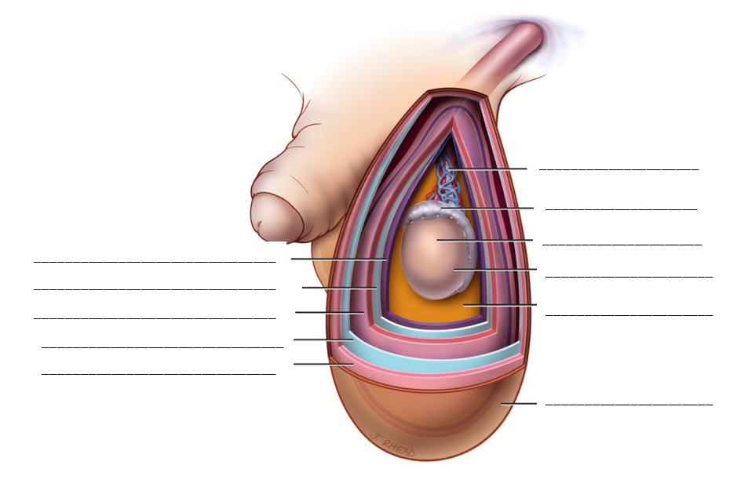

Figure: Anatomy of Male Scrotum

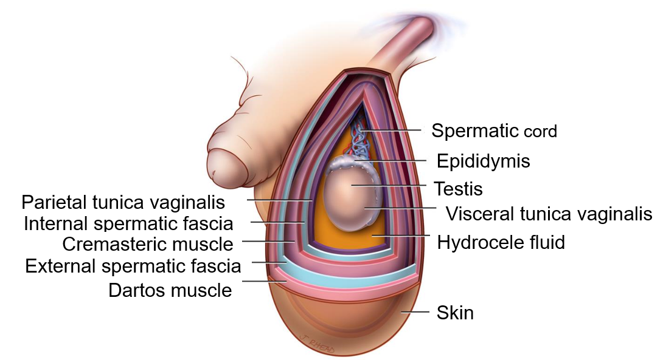

Staging and Grading Chart
Type of Hydrocele | Single | Bilateral
Side of Hydrocele | Right | Left
Stage of Hydrocele | I | Less than a tennis ball (~160ml)
 | II | Larger than stage 1. Lower pole does not extend below mid-thigh.
 | III | Lower pole extends below mid-thigh but not below upper-edge of the patella
 | IV | Lower pole extends below patella and not below the tibial tuberosity
 | V | Lower pole extends below tibial tuberosity but not below mid leg
 | VI | Lower pole extends below mid leg
Grade of Hydrocele | 0 | No visible burial of penis, no shortening of penis
 | 1 | Partial burial of penis with visible length at least 2 cm
 | 2 | Partial burial of penis with visible length less than 2 cm
 | 3 | Total burial of penis with glans or prepuce visible
 | 4 | Total burial of penis with stretched skin of prepuce causing problems with urination

Surgical Planning Algorithm
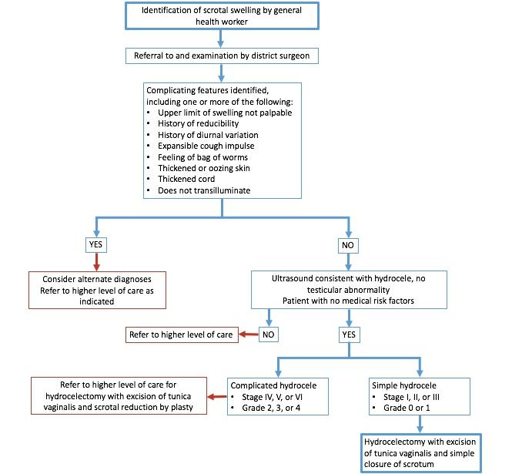

Figure: Hygienic Environment

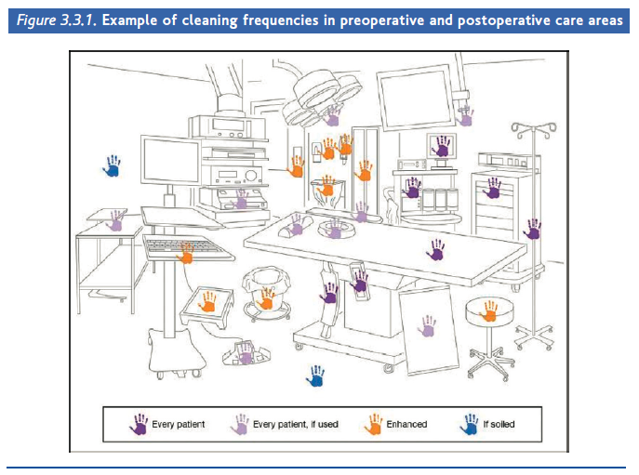

Surgical Hand Scrubbing Technique

Techniques for Tunica Vaginalis

Hydrocele Surgery Follow-Up Algorithm
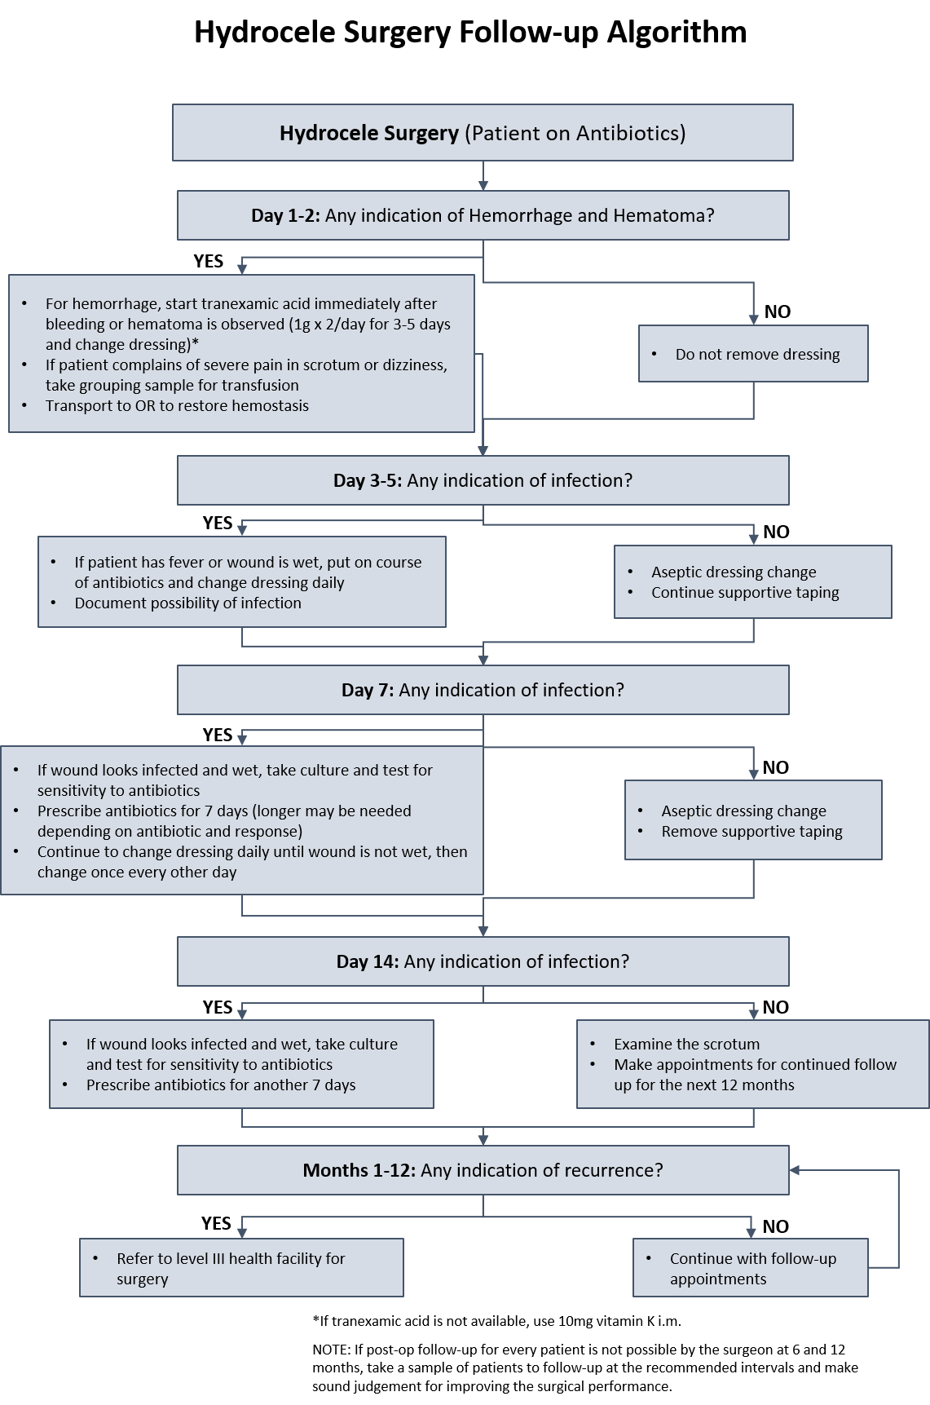

WHO Surgical Safety Checklist
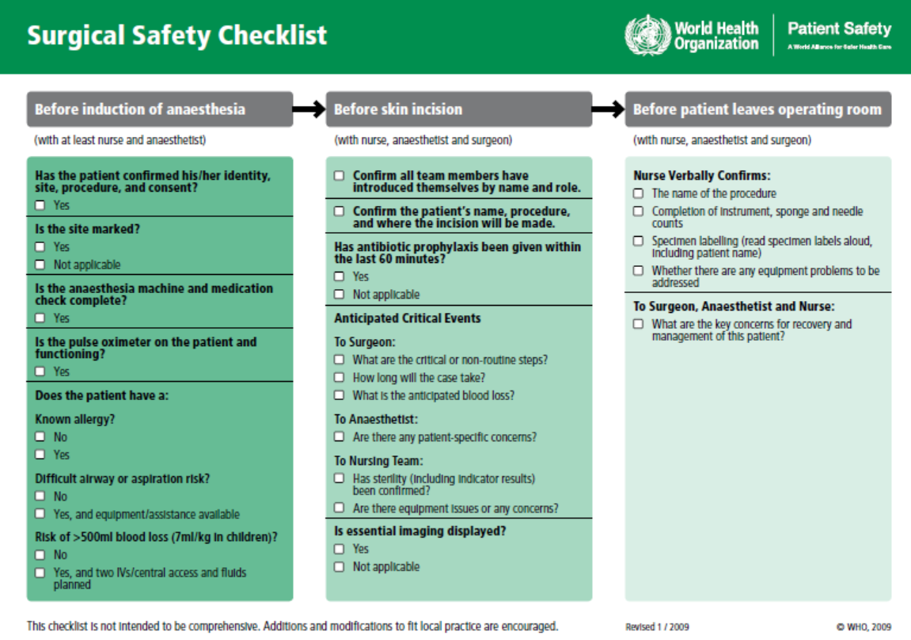

FASTT SURGICAL ASSESSMENT FORM
Surgical Skills Assessment on FASTT during solo observed practice

Surgeon Name: ____________________ Date: ______________ Instructor Name: _____________

Rating Scale: 1= Poor; 2= Mediocre; 3= Good; 4= Very good; 5= Excellent

- Cleaning, then disinfecting the genital area 1 2 3 4 5
- Midline incision 1 2 3 4 5
- Hemostasis of any bleeding 1 2 3 4 5
- Total dissection of the filaricele 1 2 3 4 5
- Emptying of fluid from the filaricele 1 2 3 4 5
- Opening the filaricele sac and inspecting the testis 1 2 3 4 5
- Performing the resection 1 2 3 4 5
- Suturing the tunica vaginalis 1 2 3 4 5
- Placing the testis back in the scrotal cavity 1 2 3 4 5
- Suturing the scrotum 1 2 3 4 5
NOTE: Any result of 2 or below requires a retraining on that step. If there are three or more steps that register a 2 or below, the surgeon should be retrained on both sides of the hydrocele cartridge using FASTT.
After a total of 2 hydrocele surgeries on FASTT, do you believe that the surgeon has acquired the recommended standardized surgical technique? (circle one) YES or NO
If no, why not? ________________________________________________________________
Suggested areas for further practice ________________________________________________ ______________________________________________________________________________

