1. Choose a good location with enough natural light (not too bright). It is very important to use natural light for photo taking. Do not use a flashlight or lamp to illuminate the eye.
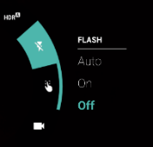
2. Check the camera settings:
Magnification is approx. 2.0 (between 1.8 and 2.2):
Flash is OFF:

3. Take a photo showing the person’s face to help track that individual over time.
4. Position yourself close to the person. Leave about 20-30 centimeters of space between the person’s face and the camera lens.
5. Position the eye at the center of the photo (using a portrait orientation).
6. Find an angle that shows the entire eyelid margin. The person’s eyes should be open.
7. Focus on the eyelid margin.
- If it is a pre-operative photo, focus on the inturned eyelashes. Stabilize the head of the person being photographed by asking him/her to rest it against a wall.
- For the immediate post-operative photo (when the person is still on the table), focus on the eyelid margin not on the sutures.
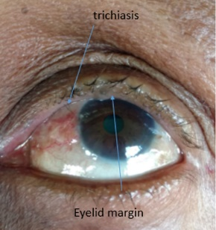
8. Take the photo by pressing the screen or the button on the side.
9. Verify the quality of the photo. Ensure that the photo
- has enough light,
- features the eye at the center of the photo,
- shows the entire eyelid margin, and
- is well-focused.
  - Pre-operative photos should focus on the trichiatic eyelashes.
  - Post-operative photos should focus on the eyelid margin (not the sutures).
