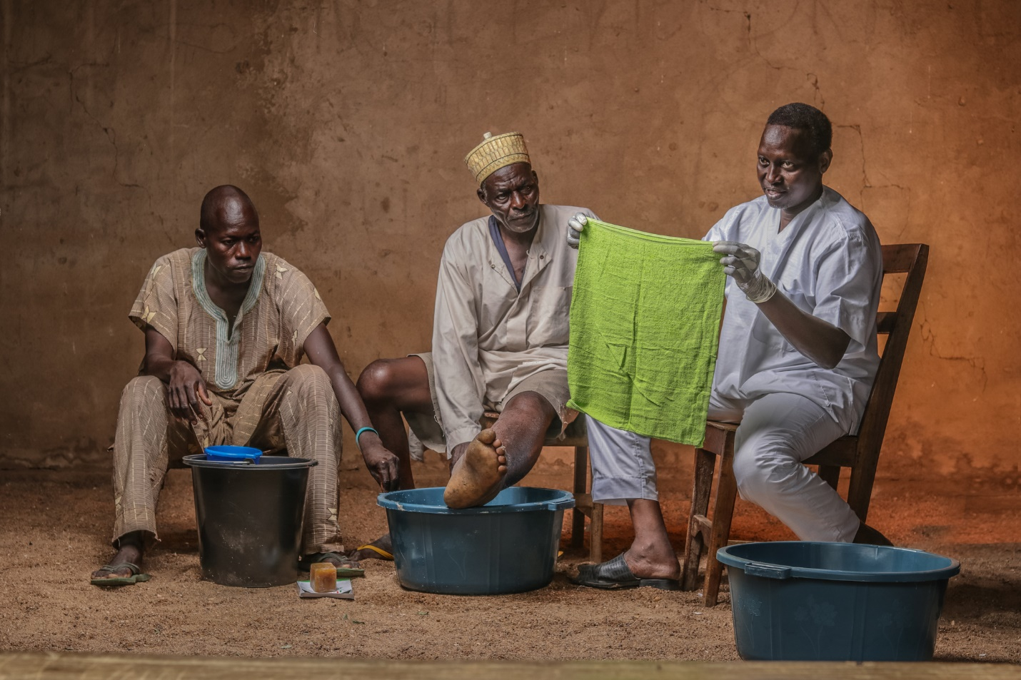

Lymphedema Management Video: Trainer’s Guide

To be used in conjuNction with THE lymphedema Management VIDEO



Trainer’s Guide to the Lymphedema Management Video
The Lymphedema Management Video is designed to serve as a support for trainers conducting a training on lymphedema management. The video is not intended to reflect an entire comprehensive training; rather, it is designed to support the trainer in reinforcing important points, such as “the dos and the don’ts” of lymphedema management. The trainer is also strongly encouraged to conduct live demonstrations for various activities (such as washing, drying, cream application, and exercise) with training participants.
To help make the video more interactive, the trainer is encouraged to pause the video regularly to explain or demonstrate key messages and to respond to questions as needed. The breaks in between video segments are designed to be used as opportunities to conduct demonstrations, facilitate discussion, and answer questions.
Additional handouts on lymphedema staging and managing lymphedema are included as an annex to this guide. These materials may be distributed to community members, health workers, and program staff as needed.
Additional points to be reinforced by the trainer for specific video segments are:
Lymphatic Filariasis
- Emphasize that although the video explains that “[the drugs] will not help people who already show signs of the disease,” it is still very important for those with lymphedema to take the medication as instructed to help prevent the further spread of disease in the community.
Lymphedema Overview
- Discuss the key components of lymphedema management: hygiene, skin and wound care, exercises, elevation, and wearing suitable shoes.
Role of Community Health Worker
- Emphasize that the community health worker should encourage: hygiene, skin and wound care, exercises, elevation and wearing comfortable shoes. (See Handout 3: Managing Lymphedema.)
- Hold conversations with training group on strategies around home visits. Participants can share their experiences and discuss strategies for building relationships with lymphedema patients and families in their communities.
- Attached handouts include information on staging of lymphedema (See Handout 1: Simplified Lymphedema Staging and Handout 2: Detailed Lymphedema Staging.)
Hygiene
- When discussing the supplies necessary for good hygiene, note that it is best to keep the soap off the ground and all supplies should be clean.
- The video notes that any knobs on the skin should be dried well after washing. The trainer should note that this also applies to mossy lesions.
- The video notes that entry lesions are typically white in color and found in between the toes and around the nail, but it is important to note that they can also be pink.
- Emphasize the importance of cleaning and drying the skin folds.
Skin and Wound Care
- Emphasize how to safely mix the potassium permanganate. Reinforce that the person can risk burning their skin if the potassium permanganate is not fully dissolved.
- Note that fresh solution should be mixed daily and potassium permanganate should be stored in the dark or in an opaque container.
Exercises
- The video serves as an entry point for the healthcare worker to give examples of other types of exercises and give live demonstrations. The goal of the video is to illustrate general movement; the video clips do not perfectly capture every aspect of proper exercise. The trainer should demonstrate proper technique for specific exercises. For example:
  - When circling the foot, the goal is to rotate at the ankle.
  - For the ‘up on toes’ exercise, advise patients that when doing this exercise they should ensure that they keep their toes on the ground when they come back down on their heels. They should avoid rocking back and lifting their toes off the ground.
  - Emphasize that the person holds on to a sturdy surface when doing some of the exercises.
  - It would be helpful for the trainer to mention exercises for the arm.
- Ensure the person’s extremity is dry before they begin exercises.
- Emphasize that exercises can be done while cooking or doing other activities.
Elevation
- Elevation can also be achieved by placing a pillow under the knee for support when the patient is lying down.
Suitable Footwear
- Emphasize the point of this segment is wearing comfortable shoes. Shoes should not irritate or harm the skin.
Acute Attack Management
- Clarify that patients experiencing an acute attack are supposed to soak the affected limb, and only asked to wash the limb with soap if washing is tolerated.
  - The video showing a person splashing the leg with water is meant to illustrate spreading cold water across the leg (not washing it).
Attachments:
- Handout 1: Simplified Lymphedema Staging
- Handout 2: Detailed Lymphedema Staging
- Handout 3: Managing Lymphedema
- Handout 4: Recommended MDA Regimen for LF (as of August 2019)

Simplified Lymphedema Staging
Mild
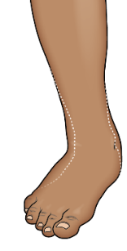 | Lymphedema without folds  Can or cannot be reversible overnight
Moderate
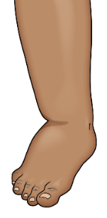 | Lymphedema with shallow folds
Severe
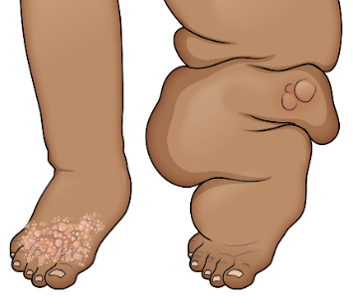 | Lymphedema with skin changes  Mossy lesions, knobs, and/or deep folds

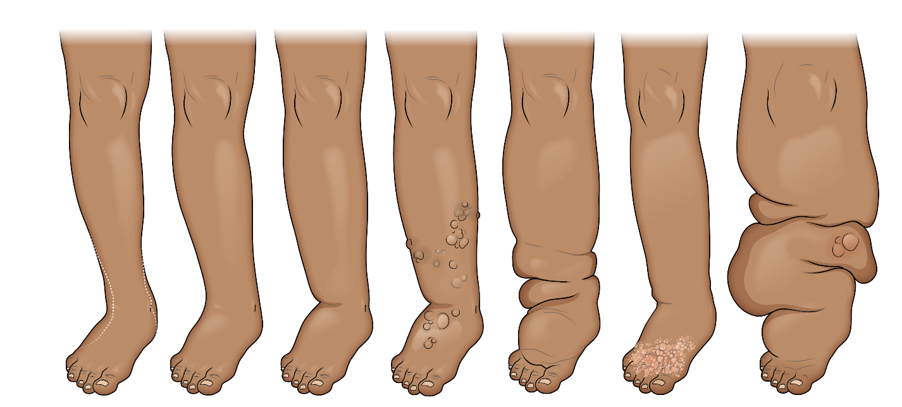
Detailed Lymphedema Staging

Mild → Moderate → Severe

Managing Lymphedema
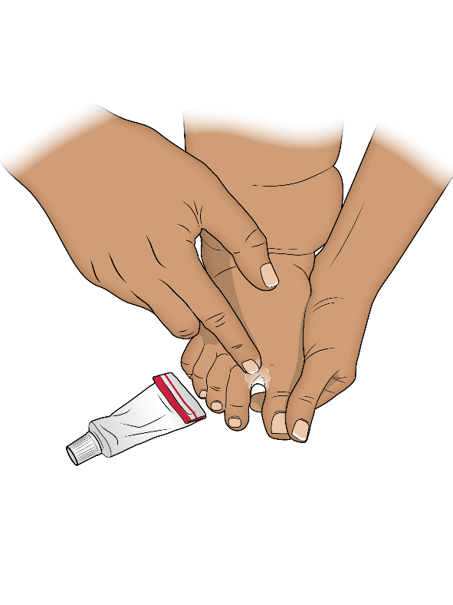
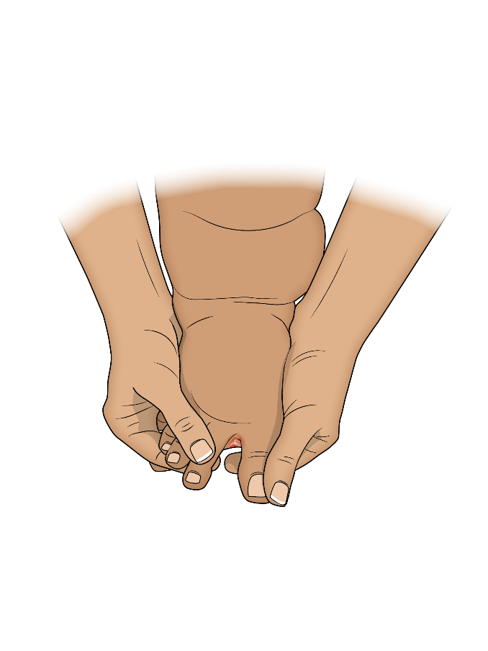
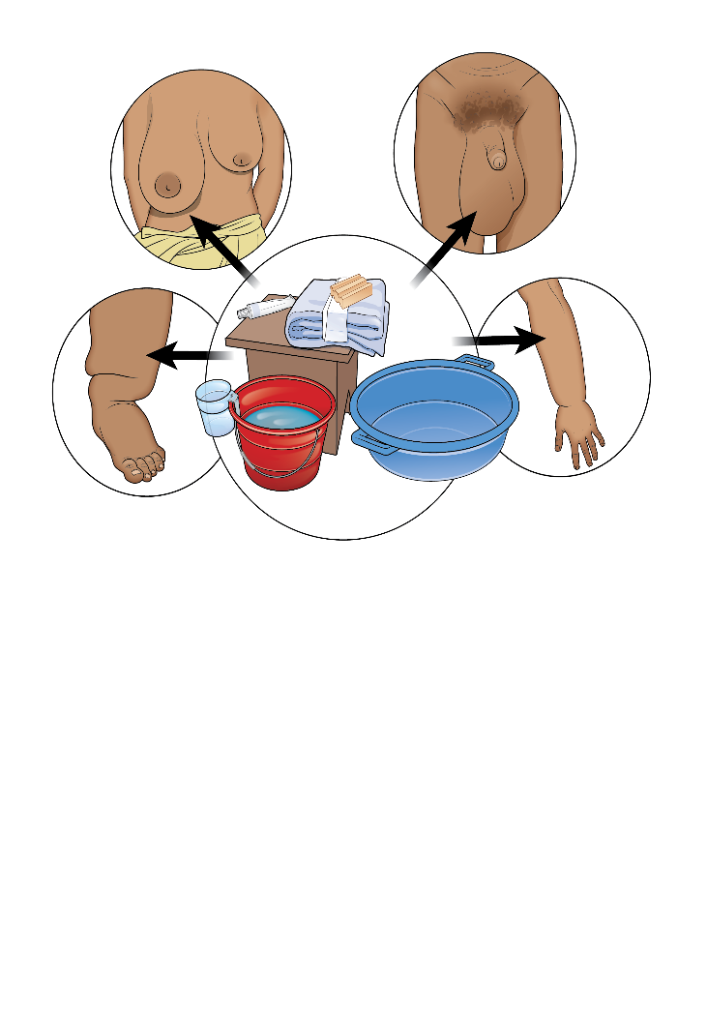
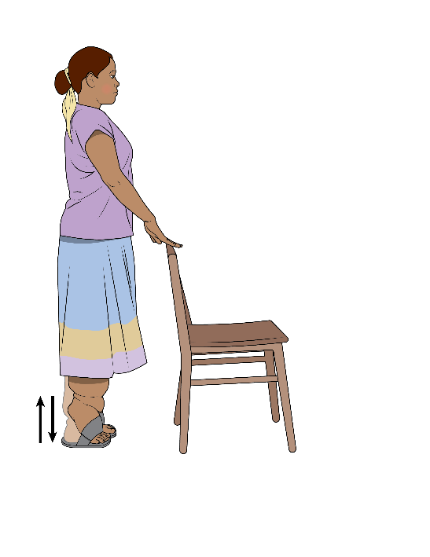
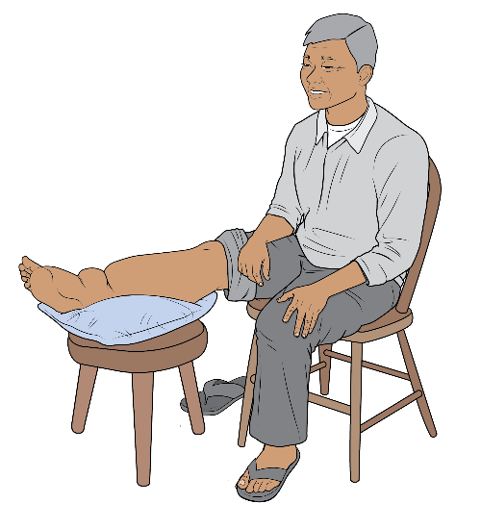
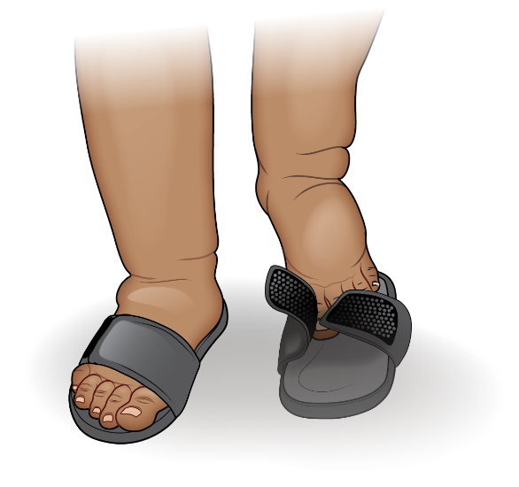
2. Skin and Wound Care
1. Washing
3. Exercises
4. Elevation
5. Wearing Comfortable Shoes
Recommended MDA Regimen for LF (as of August 2019)
Always confirm the latest WHO guidance and dosage
before administering any medication.

Onchocerciasis |  | Loiasis
In countries where LF is not co-endemic with onchocerciasis | In countries where LF is co-endemic with onchocerciasis | In implementation units where LF is co-endemic with loiasis*
Annual diethylcarbamazine citrate (DEC) + albendazole  OR  Annual diethylcarbamazine citrate (DEC) + albendazole + ivermectin | Annual ivermectin  +  Albendazole | Biannual albendazole
*Recommended regimen for LF MDA in settings where ivermectin has not been distributed to eliminate either LF or onchocerciasis because loiasis is co-endemic

